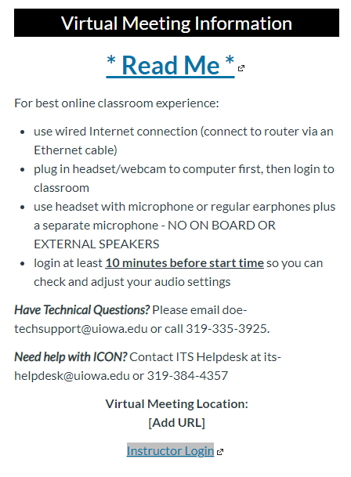
To add the Zoom “Widget” to your ICON site, first create or open the page where this info will be added. Copy the text (HTML codes) at the end of this document and follow the steps below to paste it into the Rich Content Editor. Once pasted, switch back to the Rich Content Editor and update the page as needed – be sure to save your changes.
Figure 1- Image of Zoom "widget".
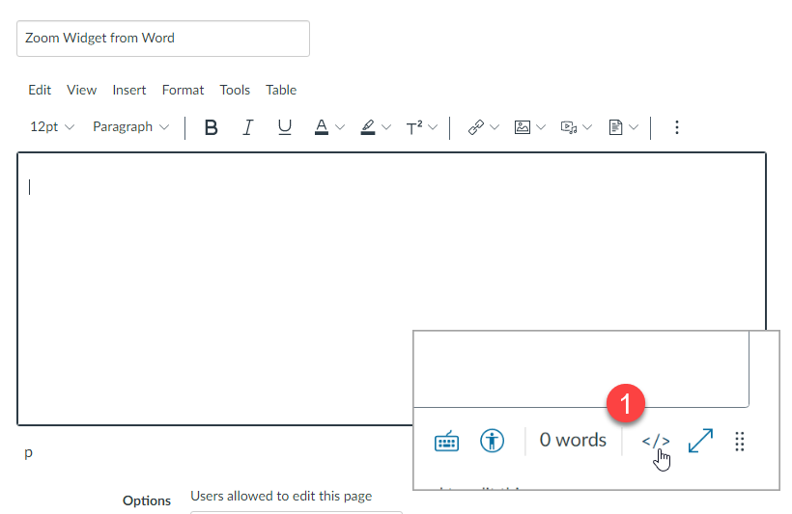

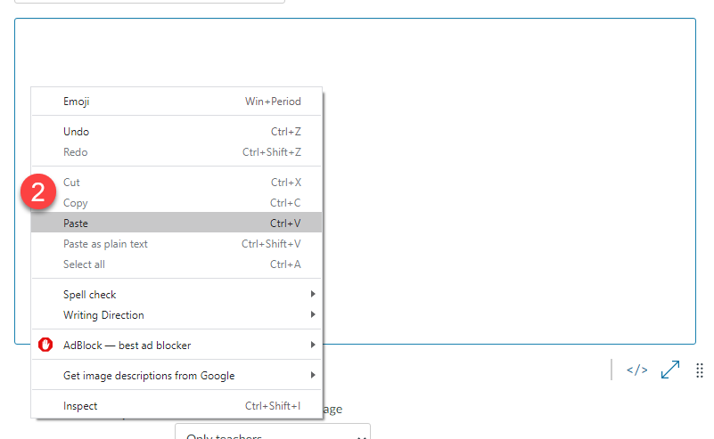
Figure 2-Step 1 - switch to HTML Editor view
Figure 3-Step 2: paste text into window
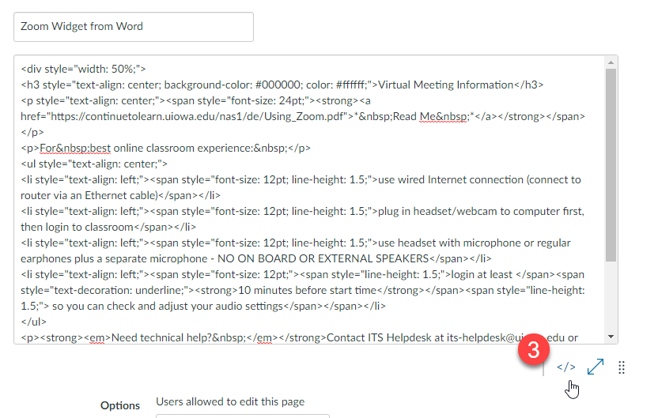
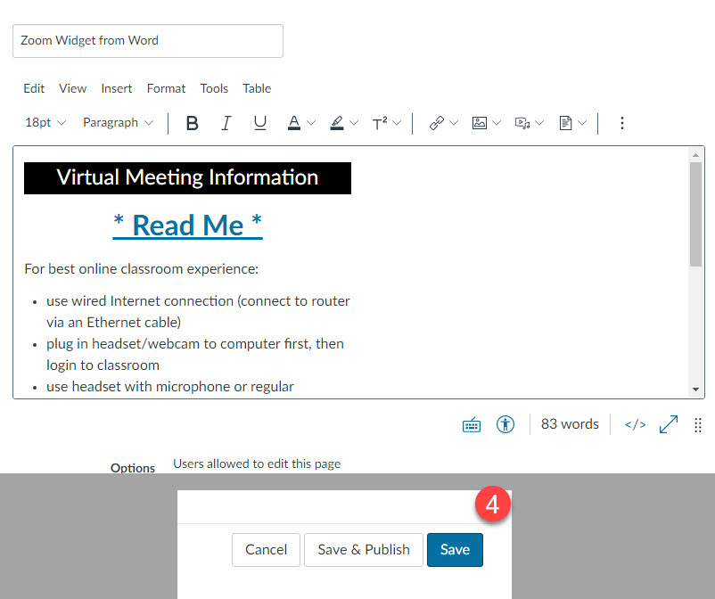
Figure 5-Step 4: update info as needed and save page
Figure 4-Step 3: switch back to Rich Content Editor
Tips: to adjust the width of the widget, change the width value in the first line (“width:50%;”). Banner title (Virtual Meeting Information) is also text and can be modified as needed.

<div style="width: 50%;">
<h3 style="text-align: center; background-color: #000000; color: #ffffff;">Virtual Meeting Information</h3>
<p style="text-align: center;"><span style="font-size: 24pt;"><strong><a href="https://continuetolearn.uiowa.edu/nas1/de/Using_Zoom.pdf">*&nbsp;Read Me&nbsp;*</a></strong></span></p>
<p>For&nbsp;best online classroom experience:&nbsp;</p>
<ul style="text-align: center;">
<li style="text-align: left;"><span style="font-size: 12pt; line-height: 1.5;">use wired Internet connection (connect to router via an Ethernet cable)</span></li>
<li style="text-align: left;"><span style="font-size: 12pt; line-height: 1.5;">plug in headset/webcam to computer first, then login to classroom</span></li>
<li style="text-align: left;"><span style="font-size: 12pt; line-height: 1.5;">use headset with microphone or regular earphones plus a separate microphone - NO ON BOARD OR EXTERNAL SPEAKERS</span></li>
<li style="text-align: left;"><span style="font-size: 12pt;"><span style="line-height: 1.5;">login at least </span><span style="text-decoration: underline;"><strong>10 minutes before start time</strong></span><span style="line-height: 1.5;"> so you can check and adjust your audio settings</span></span></li>
</ul>
<p><strong><em>Need technical help?&nbsp;</em></strong>Contact ITS Helpdesk at its-helpdesk@uiowa.edu or 319-384-4357</p>
<p style="text-align: center;"><strong>Virtual Meeting Location:</strong><br /><strong>[Add URL]</strong></p>
<p style="text-align: center;"><a href="https://uiowa.zoom.us/meeting"><span style="background-color: #c0c0c0;">Instructor Login</span></a></p>
</div><p>&nbsp;</p>

